## Chương trình logo, gridView

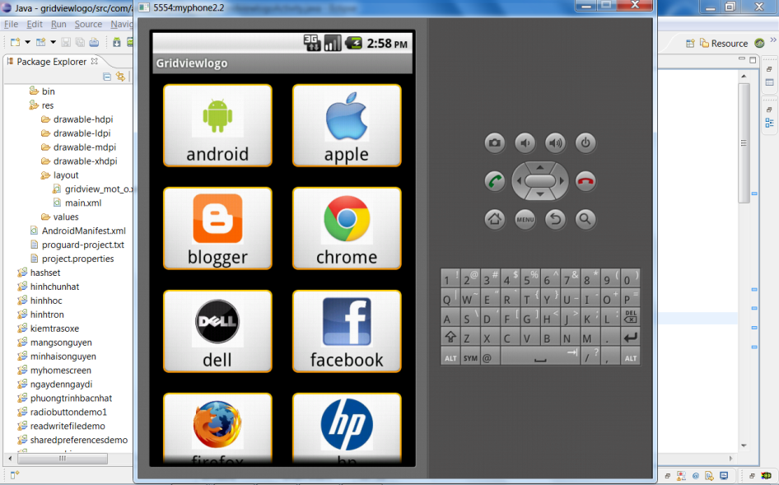

1. Tạo layout mới cho 1 ô trong gridview, **gridview_mot_o.xml**

<?xml version=*"1.0"* encoding=*"utf-8"*?>

<RelativeLayout xmlns:android=*"http://schemas.android.com/apk/res/android"*

android:layout_width=*"match_parent"*

android:layout_height=*"match_parent"*

android:background=*"@drawable/border"*

>

<ImageView

android:id=*"@+id/imageView1"*

android:layout_width=*"64dp"*

android:layout_height=*"64dp"*

android:layout_centerHorizontal=*"true"*

android:layout_alignParentTop=*"true"*

android:layout_marginTop=*"5dp"*

android:src=*"@drawable/ic_launcher"* />

<TextView

android:id=*"@+id/textView1"*

android:layout_width=*"wrap_content"*

android:layout_height=*"wrap_content"*

android:layout_below=*"@+id/imageView1"*

android:layout_centerHorizontal=*"true"*

android:text=*"Large Text"*

android:textColor=*"#000000"*

android:textAppearance=*"?android:attr/textAppearanceLarge"* />

</RelativeLayout>

1. Main.xml

<?xml version=*"1.0"* encoding=*"utf-8"*?>

<LinearLayout xmlns:android=*"http://schemas.android.com/apk/res/android"*

android:layout_width=*"fill_parent"*

android:layout_height=*"fill_parent"*

android:orientation=*"vertical"* >

<GridView

android:id=*"@+id/gridView1"*

android:layout_width=*"match_parent"*

android:layout_height=*"wrap_content"*

android:numColumns=*"auto_fit"*

android:horizontalSpacing=*"10dp"*

android:verticalSpacing=*"10dp"*

>

</GridView>

</LinearLayout>

1. Trong file java .

Khai báo 2 mảng chưa hình và tên

String[]ten={"android","apple","blogger",

"chrome","dell","facebook",

"firefox","twitter","ie",

"microsoft","hp","xbox"};

**int**[]hinh={R.drawable.*android*,R.drawable.*apple*,R.drawable.*blogger*

,R.drawable.*chrome*,R.drawable.*dell*,R.drawable.*facebook*

,R.drawable.*firefox*,R.drawable.*twitter*,R.drawable.*ie*

,R.drawable.*microsoft*,R.drawable.*hp*,R.drawable.*xbox*};

Tạo ra 1 class (vẫn nằm trong class activity hiện tại)

/////////////class đại dien cho 1 ô //////

**public** **static** **class** View_Mot_O

{

**public** ImageView imageview;

**public** TextView textview;

}

///////ket thuc class View_Mot_O///////////

Xay mot lop my adapter (cung nằm trong class activity)

**public** **class** myadapter **extends** BaseAdapter

{

Context context;

**public** myadapter(Context c)

{

context=c;

}

**public** **int** getCount() {

// **TODO** Auto-generated method stub

**return** hinh.length;

}

**public** Object getItem(**int** position) {

// **TODO** Auto-generated method stub

**return** hinh[position];

}

**public** **long** getItemId(**int** arg0) {

// **TODO** Auto-generated method stub

**return** 0;

}

**public** View getView(**int** arg0, View arg1, ViewGroup arg2) {

// **TODO** Auto-generated method stub

View_Mot_O mot_o;

LayoutInflater layoutinflater= ((Activity)context).getLayoutInflater();

**if**(arg1==**null**)

{

mot_o = **new** View_Mot_O();

arg1 = layoutinflater.inflate(R.layout.*gridview_mot_o*, **null**);

mot_o.textview = (TextView) arg1.findViewById(R.id.*textView1*);

mot_o.imageview = (ImageView)arg1.findViewById(R.id.*imageView1*);

arg1.setTag(mot_o);

}

**else**

mot_o=(View_Mot_O)arg1.getTag();

mot_o.imageview.setImageResource(hinh[arg0]);

mot_o.textview.setText(ten[arg0]);

**return** arg1;

}

}

Cuối cùng tạo gridview, gán adapter và bắt sự kiện.

gv=(GridView)findViewById(R.id.*gridView1*);

gv.setAdapter(**new** myadapter(**this**));

gv.setOnItemClickListener(**new** OnItemClickListener() {

**public** **void** onItemClick(AdapterView<?> arg0, View arg1, **int** position,

**long** arg3) {

// **TODO** Auto-generated method stub

Toast.*makeText*(GridviewlogoActivity.**this**,

"ban chọn hình thứ "+position+ " logo "+ ten[position],

Toast.*LENGTH_SHORT*).show();

}

});

## Chương trình listview người đẹp

|  |  |
| --- | --- |
|  | Dùng adapter có thể kế thừa từ BaseAdapter hoặc từ ArrayAdapter, xem lại bài listviewnguoi đẹp để xem 2 cach.  Khi lót màu nền, nếu cuộn sẽ bị xuất hiện phần đen. Dùng cacheColorHint cho màu trong suốt #00000000 (chú ý: 8 số 0 nhé) Màu nền linearlayout là "#9BA841" |

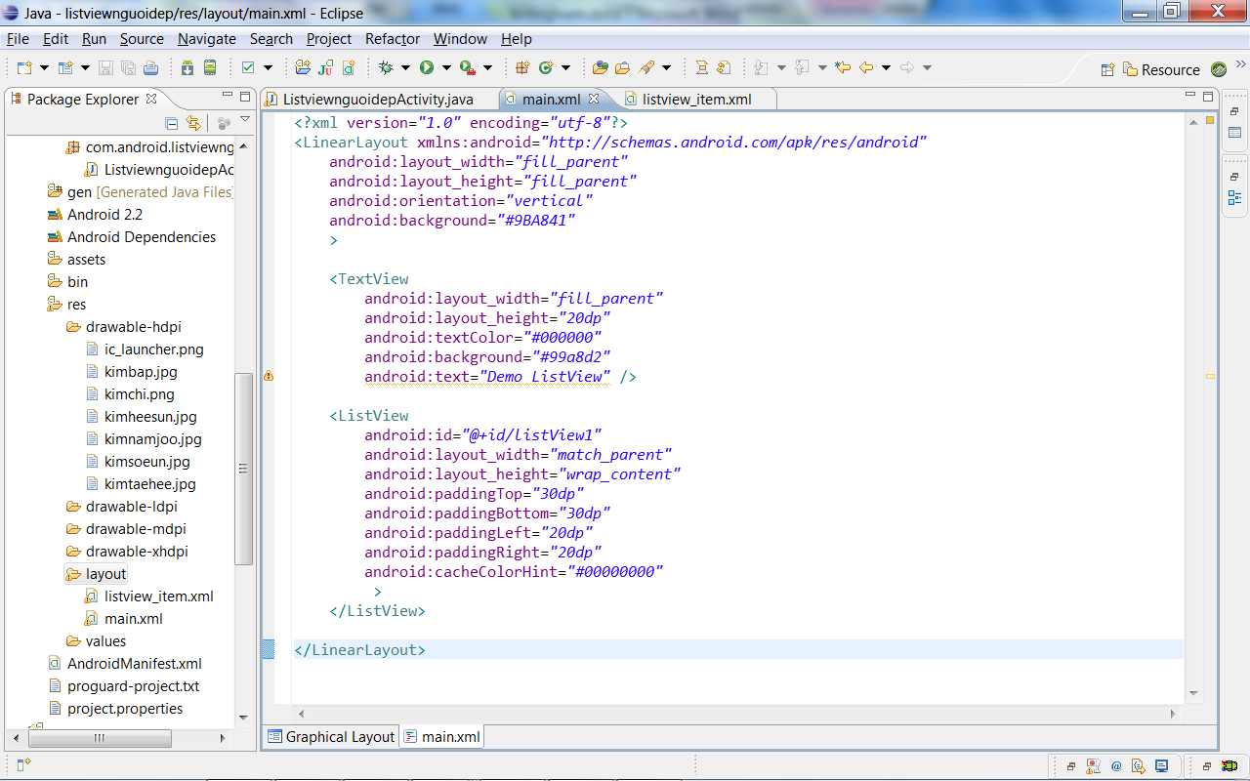

Co the do them theo dang selector , file nutdo.xml trong thu muc drawable trong bai button nang cao.

Trong getview truoc khi tra ve arg1 (hoac convertview) ta gan vao no nhu sau

arg1.setBackgroundResource(R.drawable.*nutdo*);

